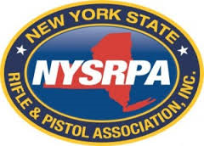
145th Annual Meeting of Members/Convention Vendor Application
Sunday March 20, 2016 10am -5pm
Long Island Hilton 598 Broad Hollow Road Melville, NY
__________________ One Merchant 10 x 10 Booth including one table $125
__________________ Non for Profit 10 x 10 Booth including one table $100
There is no outside food or drink permitted in the hotel
Company Name (as it listed on promotional materials _____________________________________________
Address ___________________________________________________________________________________
City _______________________________________ State _______________________ Zipcode __________
Brief description of product/service offered: __________________________________________________________________________________________
__________________________________________________________________________________________
Contact Name ____________________________________________ Phone Number ____________________
Email Address ______________________________________________________________________________
Method of payment
Credit Card: American Express Visa Master Charge Check made out to NYSRPA
Credit Card Number __________________________ Expiration Date _____________ Security Code _______
Remit to: New York State Rifle and Pistol Association
90 S. Swan Street Ste. 395
Albany, NY 12210

For additional information on vending spaces or sponsorships
Contact Event Coordinator Christine Schiff at cschiff@nysrpa.org 518-272-2654

